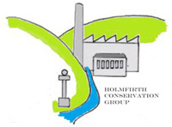

**Holmfirth Conservation Group**

**Community Briefing**

**Tuesday 28th February at Picturedrome**

**Doors open 7.30pm for 8pm start**

Come along to our fourth public open meeting where HCG will be sharing some of the provisional results of the various surveys. Take this opportunity to meet the team compiling the conservation area appraisal and share ideas with like-minded people. Enjoy extracts from the local film archive, kindly organised by the Holmfirth Film Festival, and of course, the bar will be open!

**Everyone welcome, free admission.**

(Whilst at future events we will be keen to engage children in the heritage of Holmfirth, on this occasion the event is unsuitable for those of primary age and below)

It’s not essential but please register on **EventBrite** from the **Picturedrome** website to give us an idea of numbers.

HCG would like to thank Peter Carr of **Picturedrome** for supporting this event.

Follow us on FaceBook

Website: www.holmfirthconservation.org.uk